H.T No
Regulations:
A17

Sreenidhi Institute of Science and Technology
(An Autonomous Institution)
Code No: 6B412 Date: 09-July-2021 (AN)
B.Tech II-Year II- Semester Pending External Examination, July - 2021 (Supplementary)
MACHINE DRAWING AND COMPUTER AIDED DRAWING (ME)

Time: 3 Hours Max.Marks:75

Note: a) No additional answer sheets will be provided.
b) All sub-parts of a question must be answered at one place only, otherwise it will not be valued.
c) Missing data can be assumed suitably.

ANSWER ALLTWO QUESTIONS.

1. |  | ANSWER ANYTWO FROM QUESTION 1. | BCLL | CO(s) | Marks
 | a) | Draw the sectional front view and side view of a cotter joint with socket and spigot ends used to connect two rods of 50mm diameter each .Give all necessary dimensions. | L3 | CO2 | [15M]
 | b) | Draw the sectional front view and side view of a universal coupling used to connect two shafts of 40mm diameter each. Give all important dimensions. | L3 | CO2 | [15M]
 | c) | Explain any five fundamental commands to edit a drawing (Modify commands) in AutoCAD. | L4 | CO3 | [15M]

2. | Assemble all parts of the Plummer block given in figure below. Draw half sectional front  view and the top view. | [45M]
 | 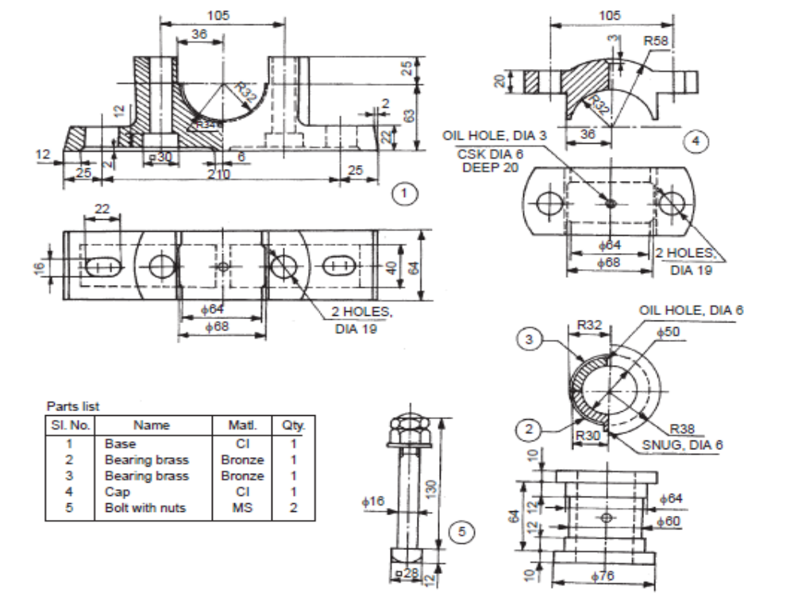

-- 00 -- 00 –

